CHEMICAL ENGINEERING TRANSACTIONS  VOL. , 2023 | A publication of
The Italian Association
of Chemical Engineering
Online at www.cetjournal.it

Guest Editors: Sauro Pierucci, Jiří Jaromír Klemeš
Copyright © 2023, AIDIC Servizi S.r.l.
ISBN 978-88-95608-98-3; ISSN 2283-9216

Aspen Plus ENRTL Model for HS3 Blend, a Novel Solvent for CO₂ Capture
Matteo Gilardi^{a,}*, Filippo Bisotti^{b,}*, Hanna K. Knuutila^{c}, Andrew Tobiesen^{b}, Davide Bonalumiª
ª Politecnico di Milano, Department of Energy, Via Lambruschini, 4A, 20156, Milano (Italy)
^{b} SINTEF Industry – Process Technology, Sem Sælands, 2A, 7491, Trondheim (Norway)
^{c} Department of Chemical Engineering, Norwegian University of Science and Technology, NTNU, Trondheim, 7491, Norway
corresponding authors - matteo.gilardi@polimi.it; Filippo.Bisotti@sintef.no
Carbon Capture and Storage (CCS) is among the main available options to cut CO₂ emissions from the industry and energy production sectors, but the high costs of current CCS technology still limit their large-scale applicability. For this reason, there is increasing interest in alternative absorbents with the potential to lower the energy and environmental impact of carbon capture. The estimation of costs, as well as process design and optimization, require accurate, reliable, and stable thermodynamic models. This article presents the development and testing of an ELECNRTL model in Aspen Plus for the characterization of HS3, an innovative blend made up of a primary (3-amino-1-propanol) and a tertiary (1-(2-hydroxyethyl) pyrrolidine) amine studied in the H2020-funded Realise project. The vapor-liquid equilibrium (VLE) model is fitted to in-house experimental data covering a wide range of loadings and operating temperatures. A plot for the system speciation in the liquid phase is obtained. Moreover, a comparison between the heat of absorption data and model prediction is also included. The proposed VLE model shows good accuracy and numerical stability in the whole temperatures and loading ranges of interest for industrial CO₂ capture applications.
  - Introduction
To limit to 1.5 °C the world temperature increase, net zero equivalent CO₂ emissions must be reached by 2050. To reach this ambitious target, several climate mitigation actions should be followed simultaneously. This implies replacing fossil fuels with renewable sources, but also capturing the produced CO₂ in power and industry sectors. The most widely adopted technique for capturing CO₂ is chemical absorption with amines. At present, the main reason why carbon capture still finds limited applicability is the high energy demand for amine solvent regeneration (Yamada, 2021). For this reason, the research aims at developing alternative blends with potentially lower energy requirements (Pellegrini et al., 2021). The HS3, a blend of 15 wt% 3-amino-1-propanol (AP) and 40 wt% 1-(2-hydroxyethyl) pyrrolidine (PRLD) is a novel solvent investigated within the EU-funded Realise project (Realise, 2022). A process simulator is needed as a tool to design and optimize the process, as well as estimate energy requirements and costs (Bisotti et al., 2022). The development and validation of an accurate vapor-liquid equilibrium (VLE) model is an essential step for applying the novel solvent and comparing its performance with other well-known solvents. VLE allows estimating of chemical and physical equilibrium occurring in the main process units (absorption, regeneration, and flashes). This contribution presents a new ELECNRTL model implemented in Aspen Plus V11.0 and its testing in the operating conditions (CO₂ loading, temperature) of interest for industrial-scale CO₂ capture. ELECNRTL has been preferred to soft model approaches since it is based on a theoretical framework and it provides an estimate of the effective system composition in the liquid phase (neutral molecules, ions, cations).
  - Theoretical background
When an amine solution is loaded with CO₂, both chemical and physical equilibrium occur simultaneously. Chemical equilibrium is usually described by a list of elementary reactions. The reactive path changes according to the amine order (i.e., primary and tertiary amine), but does not depend on the specific amine under consideration. Details on the elementary reaction scheme adopted in this work are available in the methods section. Regarding phase equilibria, amine solutions are characterized by strongly non-ideal interactions in the liquid phase between the cations and ions forming because of amine reactions with the dissolved CO₂. Thus, an activity coefficient model is recommended to define vapor-liquid equilibrium (VLE) in these systems. The Non-Random-Two-Liquid (NRTL) model proposed by Renon and Prausnitz (1969) has been extended to account for cation-anion pairs interactions with neutral molecules inside mixed solvent electrolyte systems in a wide temperature range (Hartono et al., 2021; Lin et al., 2022). The activity coefficient of each component is calculated based on a list of parameters describing the interaction of every single molecule (i) with all the other molecules and cation-anion pairs (j). The interaction parameters are furtherly classified into temperature-non-dependent (A_{ij}) and temperature-dependent coefficients (B_{ij}). These coefficients must be fitted to experimental VLE data. On the other hand, ionic interactions in the gas phase are negligible, since the volatility of charged molecules is negligible. For this reason, the gas phase can be either assumed as an ideal gas or modelled by means of any suitable equation of state. The VLE model (ELECNRTL) has already been successfully applied in Aspen Plus for the characterization of some amines and blends (Dutcher et al., 2015; Yamada, 2021).
  - ELECNRTL VLE model development
This section resumes the procedure for the developing, implementing and testing of an ELECNRTL model for HS3 solvent in Aspen Plus V11.0.
    - Elementary reaction scheme and equilibrium constants
The blend constituents follow two different paths when reacting with CO₂: the primary amine (AP) can either protonate according to (4) or turn into carbamate form (5), while the tertiary amine (PRLD) can only protonate or deprotonate as highlighted in reaction (6). Further, other reactions take place in the system without involving amines: self-ionization of water (1), hydrolysis of CO₂ (2) and carbonate formation (3). For each elementary reaction, a temperature-dependent equilibrium constant (k_{eq}) is defined according to expression (7). For each elementary reaction, a temperature-dependent equilibrium constant is defined whose general expression is (7). The list of equilibrium constants together with their sources is provided in Table 1.

$$2H_{2}O⇌H_{3}O^{+}+OH^{-}$$ | (1)
$$2H_{2}O+CO_{2}⇌H_{3}O^{+}+HC{O_{3}}^{-}$$ | (2)
$$HCO_{3}^{-}+H_{2}O⇌H_{3}O^{+}+CO_{3}^{2-}$$ | (3)
$$APH^{+}+H_{2}O⇌AP+H_{3}O^{+}$$ | (4)
$$APCOO^{-}+H_{2}O⇌AP+HC{O_{3}}^{-}$$ | (5)
$$PRLDH^{+}+H_{2}O⇌PRLD+H_{3}O^{+}$$ | (6)
$$\ln{k_{eq}}=A+\frac{B}{T}+C⋅\ln{(}T)$$ | (7)
Table 1: Molar fraction-based equilibrium constants for the chemical equilibrium for the HS3 blend. Sources: [1] Posey and Rochelle, 1997; [2] Dong et al., 2010; [3] Li et al., 2017.
 | Reaction (1) | Reaction (2) | Reaction (3) | Reaction (4) | Reaction (5) | Reaction (6)
A | 132.899 | 231.465 | 216.049 | -106.105 | 1.21526 | -10.4165
B | -13445.9 | -12092.1 | -12431.7 | -4134.2 | -1068.67 | -4234.98
C | -22.4773 | -36.7816 | -35.4819 | 16.2313
Source | [1] | [1] | [1] | [2] | [1, 2] | [3]

    - Henry constant and amines vapor pressure
Remarkably, other properties of interest for the VLE characterization such as the vapor pressure (for amines and water) and Henry constant to define the CO₂ solubility (infinite dilution condition) in the solvent are described using an Antoine-type model and the parameters using experimental data collected within the project tasks. These additional properties and the relatively detailed descriptions are available in a dedicated work by Gilardi et al. The resulting Henry constants (He) and Antoine expressions (P_{sat}) adopted in expressions (8) and (9) are gathered in Table 2.

$$\ln{(}He[kPa])=A+\frac{B}{T[K]}+C⋅\ln{(}T[K])+D⋅T[K]$$ | (8)
$$\ln{(}P_{sat}[bar])=A+\frac{B}{T[K]+C}$$ | (9)
Table 2: Henry constants (He) and Antoine equation (P_{sat}) regressed coefficients for AP and PRLD
 | P_{sat} (AP) [bar] | P_{sat} (PRLD) [bar] | He (CO₂-AP) [kPa] | He (CO₂-PRLD) [kPa]
A | 11.9628 | 20.3877 | -54.6317 | 10.9911
B | -4482.90 | -12733.55 | -2.0334 | 0.3802
C | -85.50 | 171.53 | 12.1097 | -1.1906
D |  |  | -0.0213 | 0.0130

    - Molecule-molecule and molecule-ion interaction coefficients
Equilibrium conditions in absence of CO₂ are described by means of molecule-molecule interaction parameters (NRTL). For HS3 blend, these parameters had already been fitted on binary PRLD-H₂O VLE data by Bernhardsen (Bernhardsen et al., 2019) and on AP-H₂O data by Bunevska (Bunevska, 2021). Both temperature-dependent (A_{ij} and reverse A_{ji}) and temperature-non-dependent (B_{ij} and reverse) molecule-ions interaction parameters are regressed in this work using the “Maximum likelihood” regression tool in Aspen Plus V11.0 by minimising the absolute deviation between experimental observations and model prediction using VLE data for the CO₂-H₂O-AP-PRLD system at temperatures between 40 °C and 120 °C (Hartono et al.). To start the regression, each parameter is set to the corresponding default values reported in the Aspen documentation. Interactions involving H₃O⁺, OH⁻ and CO₃²⁻ as cationic-ionic pairs are neglected as well as molecular CO₂ interactions with protonated amines and carbamate to avoid overfitting and increase model robustness and stability. This assumption is justified by the fact that the mole fractions of these species range from 10⁻⁴ to 10⁻⁹ (thus, negligible compared to other compounds). The regression is repeated iteratively using the result of the previous iteration as the initial value for the following step until the maximum observed relative discrepancy between two consecutive iterations for each parameter is lower than 5%. Finally, all B_{ij} whose absolute value is lower than 50 has been disregarded to avoid increasing the model complexity without any appreciable increase in accuracy. The obtained interaction coefficients are gathered in Table 3. Further details on the conceptual meaning and the expressions of NRTL, A_{ij}/A_{ji} and B_{ij}/B_{ji} parameters can be found in the literature (Lin et al., 2010, Aspen Plus, 2019).
Table 3: Molecule-ion interaction coefficients for the ELECNRTL model for HS3 solvent developed in this work.
Comp i | Comp j | Aij | Aji | Comp i | Comp j | Aij | Aji
H₂O | (PRLDH⁺,HCO₃⁻) | 13.696 | -5.428 | PRLD | (PRLDH⁺, APCOO⁻) | 12.549 | 2.891
PRLD | (PRLDH⁺,HCO₃⁻) | 29.044 | 8.772 | PRLD | (APH⁺, HCO₃⁻) | 11.623 | 0.116
H₂O | (APH⁺,HCO₃⁻) | 12.618 | -5.532 | PRLD | (APH⁺, APCOO⁻) | 7.460 | 19.923
H₂O | (APH⁺,APCOO⁻) | 10.523 | -6.998 | Comp i | Comp j | Bij | Bji
AP | (APH⁺, HCO₃⁻) | 87.256 | 60.379 | PRLD | (PRLDH⁺, HCO₃⁻) | 888.25 | 8810.93
AP | (APH⁺, APCOO⁻) | 20.789 | 34.801 | AP | (APH⁺, HCO₃⁻) | 1959.25 | 1514.69
H₂O | (PRLDH⁺, APCOO⁻) | 10.946 | -5.129 | AP | (APH⁺, APCOO⁻) | -259.72 | 432.83
AP | (PRLDH⁺, HCO₃⁻) | 52.332 | 35.029 | AP | (PRLDH⁺, APCOO⁻) | 530.30 | -789.54
AP | (PRLDH⁺, APCOO⁻) | 4.5923 | -1.3794 | PRLD | (PRLDH⁺, APCOO⁻) | -2337.39 | -66.63

    - Enthalpy calculations
CO₂ absorption is an exothermic process, and the released heat is defined as heat of absorption, which depends on the solvent composition and shows a weak dependency on temperature and loading. The heat of absorption for acid gases (mainly CO₂) in amine solutions must be predicted with sufficient accuracy by VLE models for process design purposes, since it directly influences the steam requirements associated with amine regeneration, thus the operating costs. The enthalpy of a generic species can be calculated in an Aspen Plus ELECNRTL model by expressions (10). These calculations require the definition of the liquid specific heat as a function of temperature for species (at infinite dilution for ions), vaporization enthalpy, as well as their enthalpy of formation (ideal gas for molecules and aqueous solution for ions). In absence of experimental observations, the formation enthalpies of AP and PRLD are approximately estimated by means of Gani’s group contribution method (Constantinou and Gani, 1994), while the formation enthalpies of protonated amines and carbamate are regressed from absorption heat data for pure AP and PRLD amine solutions at a fixed temperature using (Realise, 2022), neglecting the loading dependence. Liquid heat capacity is fitted to published and in-house experimental data (Mundhwa and Henni, 2007; Realise, 2022). The heat of vaporization is calculated from available ideal gas and liquid heat capacity data for both amines, as reported in (Gilardi et al.)

$$H_{i}(T)=ΔH_{f,i}^{0}(298.15K)-ΔH^{EV}(298.15K)+\int_{298.15}^{T}{cp_{i}^{liq}(T)⋅dT}$$ | (10)
  - VLE Model testing
The Aspen Plus VLE model for the HS3 blend has been tested against the CO₂ partial pressure experimental values (Figure 1). The ELECNRTL model can represent with sufficient accuracy the equilibrium conditions in the temperature (40°C-120°C) and loading (0.1 – 0.5 mol_{CO2}/mol_{amines}) domains of interest for both absorption and solvent regeneration. The profiles show smooth trends, allowing the model to be extrapolated at slightly higher and lower loadings with respect to the ones covered by experimental observations. The accuracy and the prediction capacity of the model are quantified by statistical indicators: the average Relative Error (RE, equation 11) and the Average Absolute Error (AE, equation 12). In these expressions, z indicates the generic variable (either CO₂ or H₂O partial pressure), i the generic experimental point and n stands for the total number of measurements.

(11)
(12)

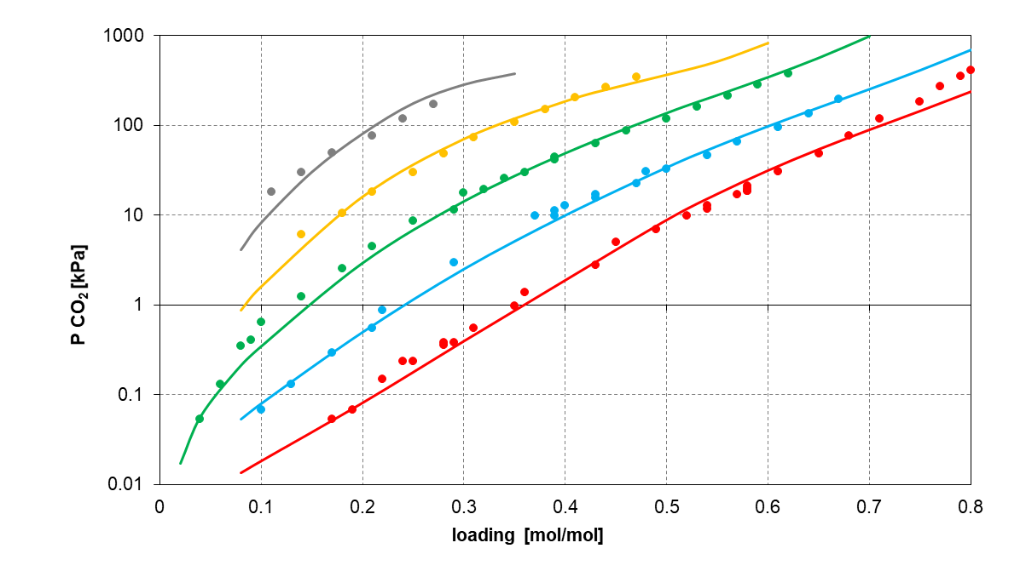
Figure 1: ELECNRTL model predictions (solid lines) and the experimental data (dots) for the HS3 blend at different temperatures: 40°C (red), 60°C (light blue), 80°C (green), 100°C (yellow), and 120°C (grey).
The statistical test is performed on CO₂ and H₂O partial pressures since these are the most abundant species in the gas phase (amines are present in traces). All VLE experimental data collected for the HS3 solvent (Hartono et al.) have been considered. The relative errors of 17.8 % and 17.0 % for CO₂ and H₂O are obtained, respectively. The mean absolute deviation is 0.07 kPa for both partial pressures.

    - Heat of absorption
The ELECNRTL model accuracy in predicting heat of absorption is estimated by comparing the reaction heat trends with loading at different temperatures with respect to experimental observations collected by Hartono et al. (Figure 2). The highest accuracy is observed at 40°C, while an apparent underestimation of absorption heat occurs at high loadings at higher temperatures. However, such observation may be caused by inaccuracies in the adopted experimental apparatus. Indeed, the monotonic profile shown by the Aspen model is more realistic and compatible with similar trends observed for other amine systems. Indeed, the presence of a double peak at intermediate loadings may be explained by the formation of some precipitates (Kim and Svendsen, 2011), which is not experienced for the HS3.

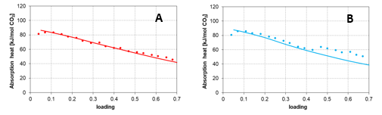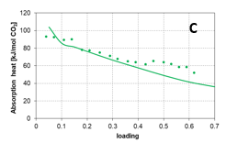
Figure 2: Aspen ELECNRTL model predictions (solid lines) and the experimental data (dots) for the HS3 blend absorption heat at different temperatures: 40°C (A), 60°C (B) and 80°C (C) data from Hartono (Hartono et al.)
    - Speciation in the liquid phase
The system speciation in the liquid phase as predicted by the ELECNRTL Aspen model is reported in Figure 3 at 40°C and 120°C, the typical operating temperatures of absorption and solvent regeneration, respectively.
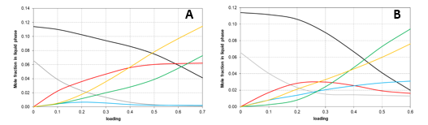
Figure 3: Speciation plot of the liquid phase predicted by the Aspen Plus model developed in this work at (A) 40 °C and (B) 120 °C. AP (grey), PRLD (black), APH⁺ (red), APCOO⁻ (light blue), PRLDH⁺ (green) and HCO3⁻ (yellow).
As expected, AP (primary amine) is more reactive than PLRD at low loadings (< 0.2), which explains its faster consumption. As PRLD reacts with CO₂, PRLDH⁺, and HCO₃⁻ are formed, while AP turns into both APH⁺ and APCOO⁻. Differently from common primary amines such as MEA, which tends to easily form carbamate rather than being protonated, for the HS3 blend amine protonation seems to be favored, thus limiting carbamate formation. Despite the lack of experimental data for the sake of comparison, this speciation plot is fully consistent with the absorption heat data in Figure 2. In fact, a progressive constant decrease of absorption heat as a function of loading is typical of tertiary amines and in general of systems where the bicarbonate path is favored, whereas carbamate forming systems are characterized by a flat absorption heat profile at loadings < 0.4.
  - Conclusions
An ELECNRTL VLE model for the characterization of the innovative amine blend HS3 in Aspen Plus has been developed exploiting both experimental data collected within the European Realise project and other literature sources. Only the 34 molecule-ion interactions having a stronger influence on the system equilibrium have been included, with a beneficial effect on the model smoothness and stability. The obtained model reproduces accurately the available VLE data in the entire temperature (40 °C – 120 °C) and loading (0.05 – 0.5) ranges of practical interest for applications in CO₂ capture. The average relative deviation between the experimental and the predicted CO₂ partial pressure is close to 17%. Moreover, an accurate estimation of absorption heat is obtained, which makes the model reliable in predicting the energy requirements of an HS3-based CO₂ capture process. The proposed ELECNRL model provides a good description of the reacting system at equilibrium, providing also details on the real composition in the liquid phase (including ions), and it may be extended in future studies to deal with AP-PRLD blends at different total and relative concentrations with respect to HS3.

Acknowledgments
This work was performed within REALISE project. The project has received funding from the European Union's Horizon 2020 research and innovation program under grant agreement No 884266 (REALISE project). For more information refers to the project webpage - Home | REALISE-CCUS (realiseccus.eu)
References
Aspen Plus®, 2019. Aspen Plus® V11.0 Documentation.
Bernhardsen, I.M., Trollebø, A.A., Perinu, C., Knuutila, H.K., 2019. Vapor-liquid equilibrium study of tertiary amines, single and in blend with 3-(methylamino)propylamine, for post-combustion CO2 capture. Journal of Chemical Thermodynamics 138, 211–228.
Bisotti, F., Fedeli, M., Prifti, K., Galeazzi, A., Dell’Angelo, A., Manenti, F., 2022. Impact of Kinetic Models on Methanol Synthesis Reactor Predictions: In Silico Assessment and Comparison with Industrial Data. Ind Eng Chem Res 61, 2206–2226.
Bunevska, T., 2021. Characterization of a solvent for chemical absorption-based CO2 capture.
Constantinou, L., Gani, R., 1997. New Group Contribution Method for Estimating Properties of Pure Compounds.
Dong, L., Chen, J., Gao, G., 2010. Solubility of carbon dioxide in aqueous solutions of 3-amino-1-propanol, in: Journal of Chemical and Engineering Data. pp. 1030–1034.
Dutcher, B., Fan, M., Russell, A.G., 2015. Amine-based CO2 capture technology development from the beginning of 2013-A review. ACS Appl Mater Interfaces 7, 2137–2148.
Gilardi, M., Bisotti, F., Tobiesen, A., Knuutila H.K., Bonalumi, D., An approach for VLE model development, validation, and implementation in Aspen Plus for amine blends in CO2 capture: the HS3 solvent case study (submitted)
Hartono, A., Ahmad, R., Svendsen, H.F., Knuutila, H.K., 2021. New solubility and heat of absorption data for CO2 in blends of 2-amino-2-methyl-1-propanol (AMP) and Piperazine (PZ) and a new eNRTL model representation. Fluid Phase Equilib 550.
Hartono, A., Carusone, F., Knuutila, H. Equilibrium behavior and the heat of absorption of CO2 of aqueous 3-amino-1-propanol and 3-amino-1-propanol - 1-(2-hydroxyethyl) pyrrolidine blends (submitted)
Kim, I., Svendsen, H.F., 2011. Comparative study of the heat of absorption of post-combustion CO2 absorbents. International Journal of Greenhouse Gas Control 5, 390–395.
Li, M., Liu, H., Luo, X., Tontiwachwuthikul, P., Liang, Z., 2017. Development of Ion Speciation Plots for Three Promising Tertiary Amine-CO2-H2O Systems Using the pH Method and the 13C NMR Method. Energy and Fuels 31, 3069–3080.
Lin, Y., ten Kate, A., Mooijer, M., Delgado, J., Fosbøl, P.L., Thomsen, K., 2010. Comparison of activity coefficient models for electrolyte systems. AIChE Journal 56, 1334–1351. https://doi.org/10.1002/aic.12040
Lin, Y.-J., Hsieh, C.-J., Chen, C.-C., 2022. Association-based activity coefficient model for electrolyte solutions. AIChE Journal 68, e17422.
Mundhwa, M., Henni, A., 2007. Molar heat capacity of various aqueous alkanolamine solutions from 303.15 K to 353.15 K. J Chem Eng Data 52, 491–498.
Pellegrini, L.A., Gilardi, M., Giudici, F., Spatolisano, E., 2021. New solvents for CO2 and H2S removal from gaseous streams. Energies (Basel) 14.
Posey, M.L., Rochelle, G.T., 1997. A Thermodynamic Model of Methyldiethanolamine-CO2-H2S-Water.
REALISE, 2022. REALISE CCUS [WWW Document].
Renon, H., Prausnitz, J.M., 1969. Estimation of Parameters for the NRTL Equation for Excess Gibbs Energies of Strongly Nonideal Liquid Mixtures. Industrial & Engineering Chemistry Process Design and Development 8, 413–419.
Yamada, H., 2021. Amine-based capture of CO2 for utilization and storage. Polym J 53, 93–102.

